**Visualization summary**

I created this Visualization Dashboard to help parents of International students who seeking to enroll in United State universities to make right decision.

The results provided in this Visualization shows step by step the enhanced detailed information that suppose to help making right choice when picking "Alma Mater"

The Dashboard is the representation of 6 visual reports.

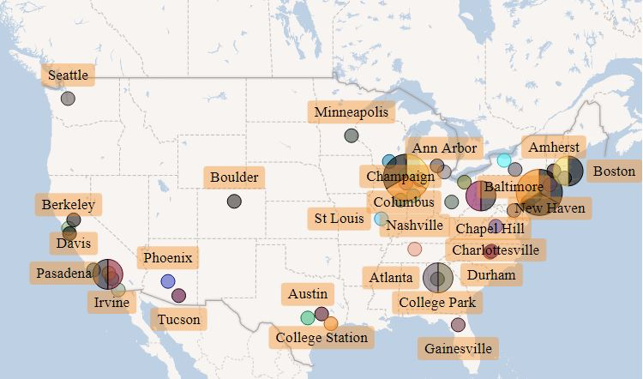

Report 1 is the general overview of the Top universities in different cities in US presented in Map format. There are several main factors such as Job Opportunities, Exposure, Campus, Cost and etc. that can impact students experience based on the location of the university. Visually inspecting the map, we can make the conclusion that majority of top US universities are located in North East Coast. That’s why it is always good practice to get to know area before making final decision.

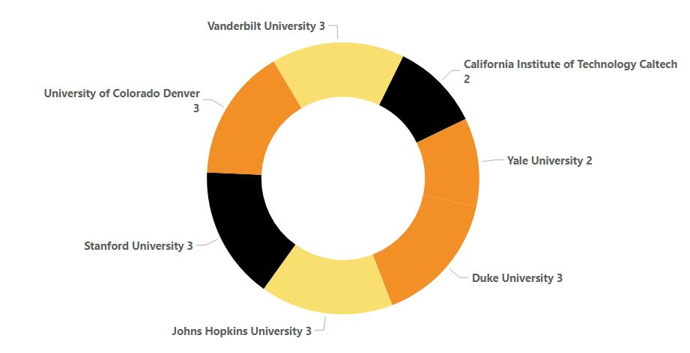

The Pie chart shows Student-Faculty Ratio of universities. This measure allows students to see what is the learning and teaching environment of the university. The more academic staff that are available per student, the more we may assume that a university well- resourced their teaching commitments. Thus, in our case, Caltech and Yale University are the best universities by student-faculty ratio parameter.

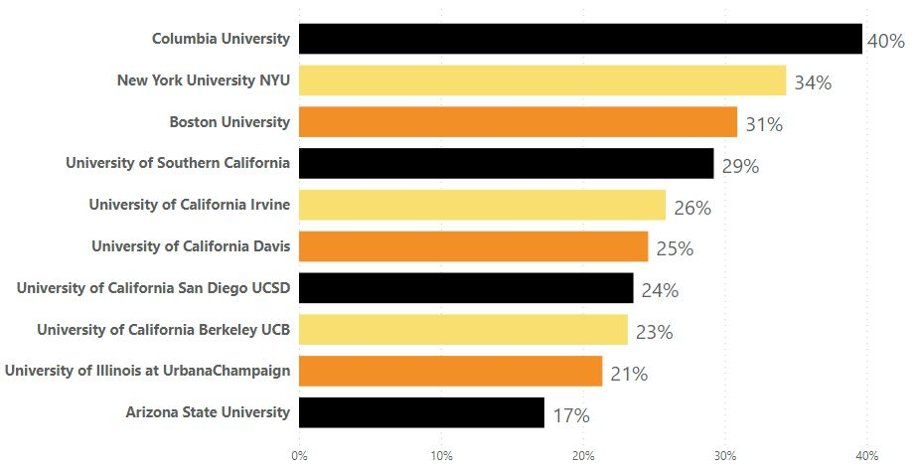

The stacked bar chart gives us the list of universities with the percentage of international students of all students on campus. This measure illustrates how attractive is that university to international students and staff and it will allow students to assess which universities will give them internationalization experience.

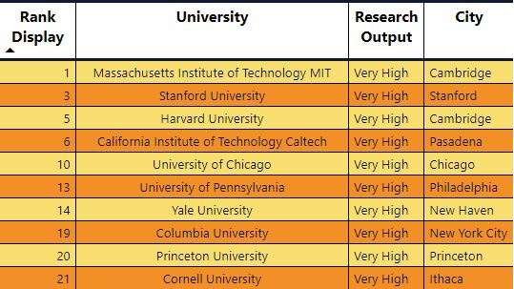

This table provides more detailed information about Top 10 universities in United States. It allows to students and their parents to see what city has which university and what its standing on world ranking is. In addition there is “Research Output” measure which helps to evaluate current situation of particular university in research field and everything related with it. That might be very useful to have perspective on academic and publication health of university.

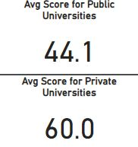

This measure illustrates the average score of Top 100 United States universities separately for Private and Public. These way potential students and their parents have an idea which type of university has bigger chances of having higher score. Also, for students who have no preferences of university, this illustration gives the general picture of university industry. In our research, in average private universities tend to have higher score.

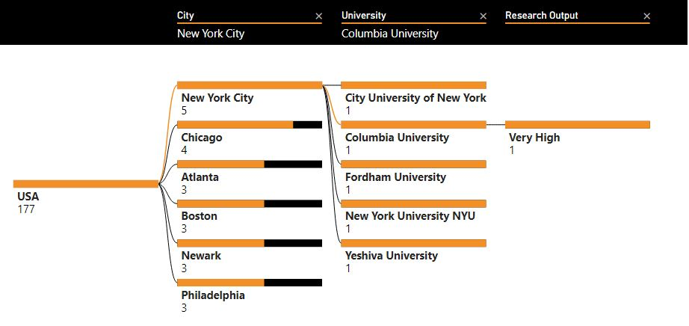

This university ranking tree shows in a descending order which cities have the most number of the top ranked universities and their research output results. For instance, in United States, New York City and Chicago have five and four top ranking universities respectively. It means the chances of getting to US top university is higher if potential student will decided to relocate in one of them.